**Group Members:**

Syeda Areesha Najam (sn05985)

Shalin Amir Ali (sa06132)

Sana Fatima (sf06199)

**Particle Swarm Optimization (PSO)**

**Project Description:**

* This project will look in to following:
* What is PSO?
* Where did it come from (inspiration)?
* What are its applications?
* How does this algorithm works/ functions?
* Analyze the complexity and efficiency of PSO algorithm.
* Particle Swarm Optimization (PSO):
  + A technique in artificial intelligence (swarm intelligence) to solve a numerical optimization problem.
  + Basically, goal is to minimize error terms (difference between actual answer and predicted answer).
  + Based on metaheuristic ( a higher level procedure used to find optimal solution for any optimization problem with imperfect data or limited computation capacity)
  + A population based stochastic (something randomly determined) algorithm.
  + Initial example is of predicting score of a football team using a math equation.
* Inspiration of PSO:
  + From social foraging behaviors of animals like birds’ flocking, schooling of fishes etc.
  + Hence, it is also classified as swarm intelligence algorithm like bacterial foraging algorithm, ant colony algorithm etc.
  + Each animal (specie) in swarm is considered as particle having its own speed and movement.
* Function:
  + PSO works on collection of particles.
  + Iteratively, values for position and velocity for each particle are updated.
  + Velocity for each particle is calculated using an equation and then updated.
  + Position of each particle is updated with respect to neighbor’s position.
  + With increasing number of iterations values reach to closer to optimal solution.
  + Much like a group of birds in search of food gets closer to actual location of food with increasing iterations and finally reach to it.
  + Stimulates swarms’ behaviors for optimization, iteratively.
  + It is aimed to update swarm’s best position.
* Data Structures:
  + In this project we will provide Python implementation of PSO algorithm using list and dictionary data structures for storing and iterating values.
* Flowchart of standard PSO:

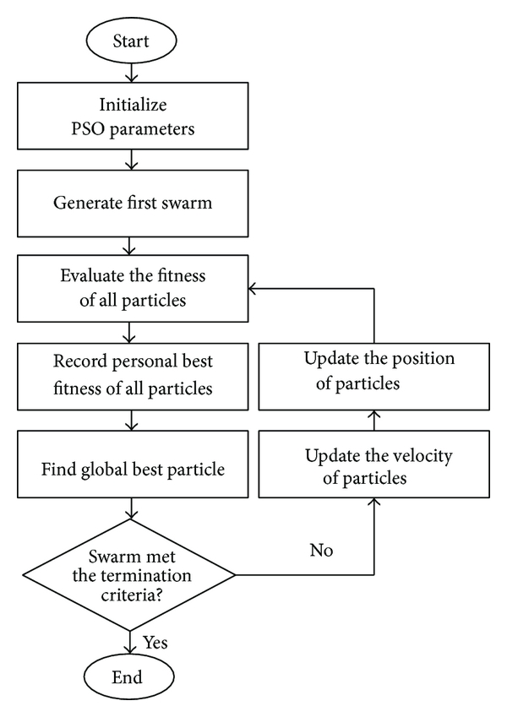

**Project Outcomes:**

* Why study PSO and why is it preferred the most amongst other optimization algorithms?
  + PSO has been widely used in continuous optimization problems because of its speed, accuracy and better performance amongst other optimization algorithms. Through this project we will analyze the efficiency and robustness of PSO algorithm.
  + PSO algorithm is able to solve complex optimization problems using swarm intelligence that is why many of the problems related to science and engineering discipline have been solved using PSO algorithm. Also its simple implementation makes it one of the best optimization algorithms.
  + Hybrid PSO algorithms are being introduced to improve the performance and efficiency of PSO algorithm to reach a more accurate optimal solution.
* Applications of PSO :
  + PSO can work effectively for all those optimization problems which can not be mathematically modeled.
  + Applications of PSO are found in variety of fields ranging from engineering design, process optimization, to service oriented applications in healthcare and bioinformatics. Some of them are listed below.
* Heart Disease Prediction System:
  + It is important to track patients exact condition with respect to other diseases linked to the heart (chest pains, heart attacks).
  + Earlier, using the traditional method/technique to predict such diseases, were inefficient and inaccurate.
  + An efficient way is the binary PSO, which divides the working of the system in two parts i.e. prediction model and performance model.
* The Analysis of Basketball Free Throw Trajectory using PSO Algorithm:
  + PSO algorithm can be used to track the ball while playing basketball.
  + The research determined that there is a significant relation between the height and shape of free throw trajectory.
  + This method can also be used while training the players in order to improve their performance of free throw.
* Micro strip antenna design using neural networks optimized by PSO:
  + Micro strip antenna, used for global positioning satellite.
  + It has become very demanding because of its small dimensions and low cost of production.
  + Design parameters of micro strip require high accuracy and calculations, the known models give less accurate results.
  + The demand for more accurate and fast computations can be satisfied using neural networks which are optimized by PSO.
* Prediction model of PSO-BP neural network on amount of coliform in food and drinking water:
  + Coliform is a bacteria which is already found mostly in the drinking water and sometimes in food.
  + They are usually not as harmful as other bacteria but some such as few strains of E.Coli cause illness which are often associated with the outbreak of disease.
  + PSO along with BP are used to predict the amount of coliform bacteria in different foods and drinks.

**Libraries/Resources to be used:**

<https://nathanrooy.github.io/posts/2016-08-17/simple-particle-swarm-optimization-with-python/>

<https://jamesmccaffrey.wordpress.com/2015/06/09/particle-swarm-optimization-using-python/>

<https://www.intechopen.com/books/particle-swarm-optimization-with-applications/introductory-chapter-swarm-intelligence-and-particle-swarm-optimization>

<https://ieeexplore.ieee.org/document/6684759>

<https://www.sciencedirect.com/science/article/pii/S1319562X19301160>

<http://www.moldbacteriafacts.com/what-are-bacteria/what-is-coliform/>

<https://www.hindawi.com/journals/tswj/2014/973093/fig1/>